**DEVELOPMENT OF VERMICOMPOSTING MONITORING**

**SYSTEM IoT AND ARDUINO MODULE**

**Abstract—Vermicomposting is a low-cost technology that naturally converts organic wastes into organic fertilizers, commonly called vermicompost, through the combined action of earthworms and mesophilic microorganisms.** **Vital parameters, such as moisture, temperature and CO2 level must be considered in the vermicompost production to achieve optimum yield. The system which monitors these vital parameters and determines the readiness of vermicompost is developed. The system uses Arduino Nano microcontroller, sensors, and an android phone for monitoring.**

INTRODUCTION

Vermicomposting is a sustainable method of recycling nutrients and energy from organic materials like food waste and paper products. It uses earthworms and microorganisms to break down, accumulate, detoxify, and convert waste materials into a product that can be used for agricultural purposes.

Eudrilus worms, particularly Eudrilus eugeniae, play a vital role in vermicomposting by efficiently decomposing organic matter, rapidly processing large quantities of waste, and exhibiting a high reproductive rate. These worms foster a symbiotic relationship with microorganisms in their digestive tracts, leading to enhanced microbial activity that breaks down complex compounds into nutrient-rich vermicompost. Their prolific breeding contributes to increased composting efficiency, while the resulting vermicompost improves soil structure, aeration, water retention, and nutrient availability. Eudrilus worms' adaptability to various conditions and low maintenance requirements make them well-suited for both indoor and outdoor vermicomposting systems, offering an eco-friendly and effective way to convert organic waste into valuable soil amendments.

Two of the vital parameters that needs consideration in a vermicomposting system are moisture and temperature. The worm bedding must be able to hold enough moisture because they breathe through their skin. A moisture level less than 50% is fatal to worms. Also, maintaining temperature within the worms’ tolerance is important to both vermicomposting and vermiculture processes. According to Macabuhay, moisture level must be maintained at around 60-80% in Philippine setting so that microbial activity is high and food matter is easy to feed up. Studies show that Eudrilus euginiae have preferences for high temperature, with maximum biomass production occurring from 25°C – 30° C, while growth rates were very low at 15°C .

The system consist of Arduino nano microcontroller which constantly sense pH value, temperature and CO2  level in compost through temperature sensor (DS18B20), pH gel electrode sensor, CO2  sensor (MHZ19E). Then these values are uploaded in an IoT system.

The system consist of Arduino nano microcontroller which constantly sense pH value, temperature and CO2  level in compost through temperature sensor (DS18B20), pH gel electrode sensor, CO2  sensor (MHZ19E). Then these values are uploaded in an IoT system.

The system consist of Arduino nano microcontroller which constantly sense pH value, temperature and CO2  level in compost through temperature sensor (DS18B20), pH gel electrode sensor, CO2  sensor (MHZ19E). Then these values are uploaded in an IoT system.





Flow Control

The system consist of Arduino nano microcontroller which constantly sense pH value, temperature and CO2  level in compost through temperature sensor (DS18B20), pH gel electrode sensor, CO2  sensor (MHZ19E). Then these values are uploaded in an IoT system

Vermicomposting is the process of turning agricultural waste into compost with the help of worms and microorganisms. It is an efficient process that is also energy-saving, cost-effective, and highly controlled.One such IoT-based vermicomposting system uses an Arduino Nano board, pH sensor, CO2 sensor, and temperature sensor.

Vermicompost is the method of using earthworms to transform organic waste into nutrient rich compost. Soil earthworms play an important role in agriculture, it decomposes dead organic litter by consuming them and release as castings. The earthworms accelerate decomposition of plant litter and organic matter and improve soil fertility by releasing mineral elements in the forms that are easily uptake by plants (Curry, 1987). Vermicompost contains most nutrients in plant available form such as nitrates, phosphates, exchangeable calcium and soluble potassium (Edwards, 1998; Orozco, 1996). The behavioural activity of earthworms that is feeding, burrowing and casting, modify the physical, chemical and biological properties of organic matter and soil for plant growth and nutrient acquisition. Due to large surface area, vermicompost offers several micro sites for nutrient retention and exchange and microbial activity (Shi-wei and Fu-Zhen, 1991). Vermicompost is usually rich in microbial populations and diversity particularly fungi, bacteria and actinomycetes (Edwards, 1998; Tomati et al., 1987). The compost prepared by earthworm contain several types of enzymes, hormones, vitamins, antibiotics and many essential nutrients needed for plant growth and also play important role in improving soil structure and water holding capacity, thereby improving crop productivity and quality. Vermicompost is characterized by high porosity, aeration, drainage, water holding capacity and microbial activity (Edwards and Burrows, 1988; Atiyeh et al., 1999, 2000).

As a whole, due to their different production processes, vermicompost might exhibit different physical, chemical and chemical features, which influenced plant growth and overall morphology in diverse ways. Thus, application of vermicompost as organic manure in soil built-up organic carbon, improve nutrient status, enhance cation exchange capacity, microbial activities, microbial biomass carbon and enzymatic activities.

This research explores the integration of Internet of Things (IoT) technologies into vermicomposting, aiming to enhance the efficiency and management of the composting process. The system utilizes Arduino Nano microcontrollers, pH sensors, CO2 sensors, and temperature sensors to monitor key environmental parameters. Real-time data collected from the composting environment is transmitted wirelessly to a central server for analysis and visualization.

CONTROLLING

In this paper, we are collecting the physical parameter of the Vermicompost. We are trying to improve the production of vermin composting with maintaining its physical condition, so that it can help in production without degrading the soil fertility. With the help of Arduino Nano we design the system. With input devices, ultrasonic sensor, temperature, CO2 and pH sensor to collect data from manure

The Arduino Nano microcontroller acts as the central processing unit, orchestrating data acquisition from the connected sensors. A pH sensor ensures optimal acidity levels, a CO2 sensor monitors composting activity, and a temperature sensor gauges the thermal conditions crucial for the proliferation of composting organisms. The IoT architecture enables remote monitoring and control, facilitating timely interventions and adjustments.

The findings of this study demonstrate the potential of the IoT-based vermicompost system in optimizing composting processes, ensuring a conducive environment for earthworms, and ultimately promoting sustainable waste management practices. The integration of various sensors enhances the system's adaptability to different composting scenarios.

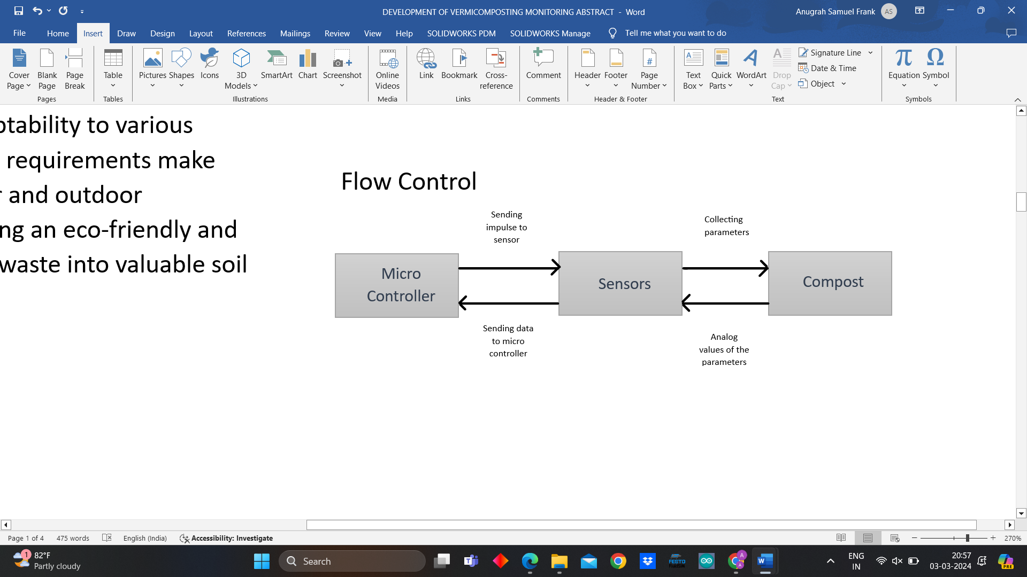

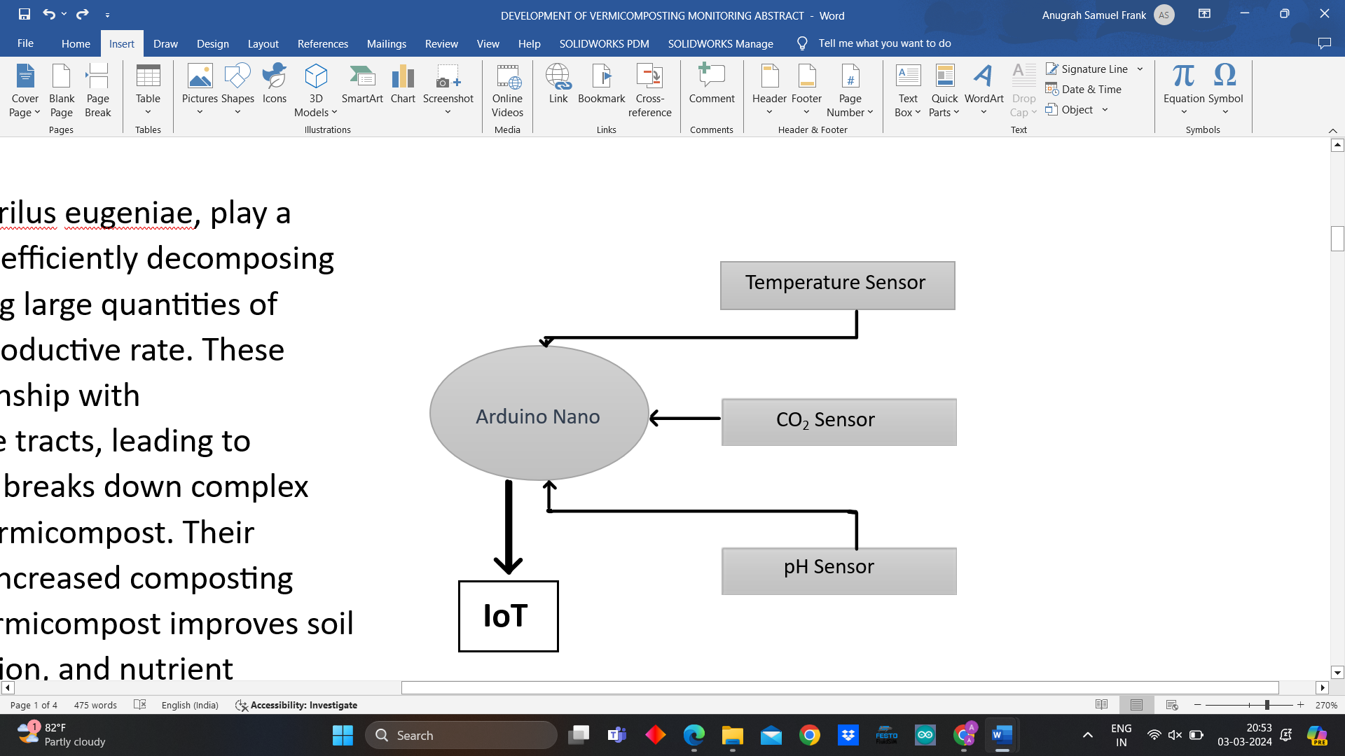



**N,P,K**

COMPONENTS USED

* DS18B20 Temperature Sensor
* Soil Moisture Sensor
* pH Sensor
* CO2 sensor
* Soil NPK sensor

**Electrical Circuit**



**5V**

**GND**

**D I G I T A L**



**ANALOG**

Arduino

Temperature Sensor



4.7K OHM

**GND**

**POWER**

**SUPPLY**

**5V**

Capacitive Soil Moisture Sensor



**4.7k ohm**



Analog pH Sensor



BNC Connector



**12V**



Soil npk sensor



Analog Infrared CO2 sensor

Connector

Interface Module



**Output and IOT Diagram**

The diagram shows the various components of the circuit and how they are connected to each other. Signal is sent by Arduino to vacillate sensors to perform action then sent output to IOT System

CO2 sensor

Analog pH Sensor

Temperature Sensor

Connector

BNC Connector

Capacitive Soil Moisture Sensor

Micro controller

PC

**input**



**input**



**output**



**input**



**input**



**OUTUP BY SENSORS**



**output**



IOT



**input**



MAX485 TTL to RS-485 Interface Module



Soil NPK sensor

**output**



OUTCOME OF THE PROJECT

**Nutritional value of vermicompost**

The nutrients content in vermicompost generally depends on the waste material or base substrate that is being used for vermicompost preparation. Similarly, earthworm species used in vermicomposting may also influence the quality of vermicompost (Chowdeppa et al., 1999). Vermicompost produced from banana wastes (leaves, pseudostem) and cattle manure in the ratio of 8: 1 on an average contained 1.5, 0.4 and 1.8% N, P2O5 and K2O, respectively (Ushakumari et al., 1999). Similarly, vermicompost prepared from different organic materials such as sugarcane trash, ipomea, parthenium, neem leaves and banana peduncle is highly nutritive and increased rice productivity and improved soil fertility status (Vasanthi and Kumaraswamy, 1999). So, the nutritive value of vermicompost is highly dependent on base substrate used for its production. However, average nutrient concentration in the vermicompost is given in Table.

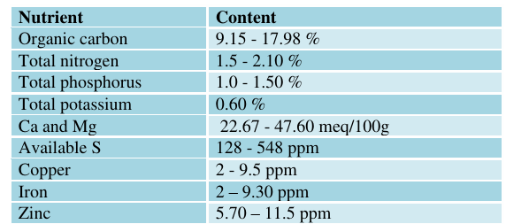

**Comparison between nutritive value of vermicompost and farmyard manure:**

The nutrient profile in vermicompost is generally higher than traditional compost (Boral et al., 1997) and it reduced the application of inorganic fertilizer to a significant extent. However, nutritive value of vermicompost varies according to the type of organic waste used.

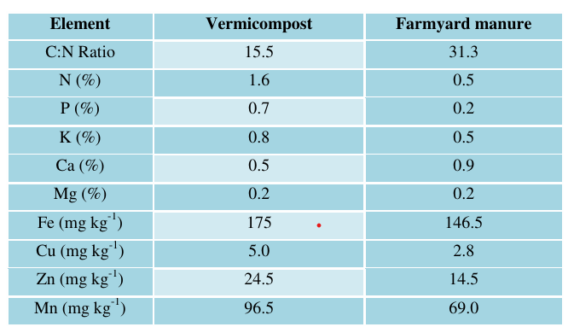

**Effects of vermicompost on soil organic matter:**

Earthworm casts ingested soils often have much higher content of soil organic carbon and nutrients availability as compared to surrounding soils (Lee, 1985). The studies undertaken by Maheswarappa, (1999) revealed that vermicompost addition in soil enhanced organic carbon status, decreased bulk density, improved soil porosities and water holding capacities, increased microbial populations and dehydrogenase activity in the soils. It has been documented that organic matter content in worm casts was about four times more than in surface soil with average values of 48.2 and 11.9 g kg-1 soil, respectively (Khang, 1994). Moreover, earthworms contribution to N turnover in cultivated soils ranged from 3 to 60 kg ha-1 year-1 (Crossley, 1988; Bostom, 1988), thereby enhancing N availability to plants (Tiwari et al., 1989; Hullugalle and Ezumah, 1991).

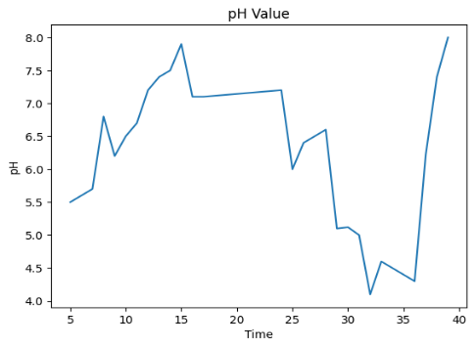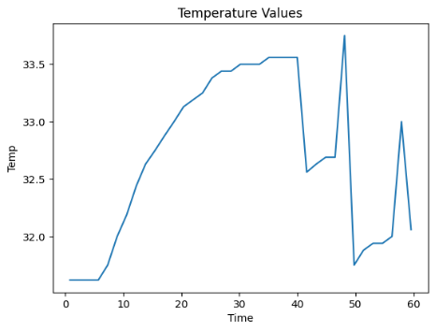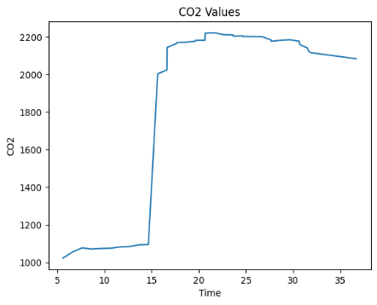

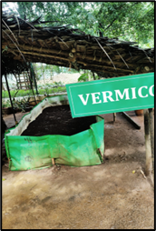

REFERENCES

* Adhikary, S. 2012. Vermicompost, the story of organic gold: A review. Agricultural Sciences, 3(7): 905-917.
* Alves, W.L., and Passoni, A.A. 1997. Compost and vermicompost of urban solid waste in Licania tomentosa (Benth) seedlings production to arborization. Pesqui.
* Agropecu Bras, 32 (10): 1053-1058. Angadi, V.V., and Radder, G.D. 1996. In: Organic Farming and Sustainable Agriculture. National Seminar, G.B.P.U.A.T, Pantnagar. pp. 34.
* Arancon, N., S. Lee, C. Edwards, and Atiyeh, R. 2003a. Effects of humic acids derived from cattle, food and paper-waste vermicomposts on the growth of greenhouse plants. Pedobiologia, 47 (5): 741-744.
* Atiyeh, R.M., N.Q. Arancon, C.A. Edwards, and Metzger, J.D. 2000. Influence of earthworm-processed pig manure on the growth and yield of greenhouse tomatoes. Bioresour. Technol, 75: 175-180.
* Atiyeh, R.M., S. Subler, C.A. Edwards, and Metzger, J. 1999. Growth of tomato plants in horticultural potting media amended with vermicompost. Pedobiologia, 43: 724-728.
* Atiyeh, R.M., S. Subler, C.A. Edwards, G. Bachman, J.D. Metzger, and Shuster, W. 2000. Effects of Vermi-composts and Composts on Plant Growth in Horticultural Container Media and Soil. Pedobiologia, 44: 579-590.
* Boral, E., C. Sachin, and Aranda, E. 1997. Earthworm activity aggregation. Soil affects Biology Biochemistry, 29 (3): 431–439.
* Lee, K.E. 1985. Earthworms, their Ecology and Relationships with Land Use. Academic Press, Sydney, pp. 411.
* Lee, K.E. 1992. Soil Bio Biochem, 24: 1765 1771. Lim, S.L., T.Y. Wu, P.N. Lim, and Shak, K.P. 2015. The use of vermicompost in organic farming: overview, effects on soil and economics. Journal of Science and Food Agriculture, 95 (6): 1143-1156.
* Suthar, S.; Singh, S. Vermicomposting of domestic waste by using two epigeic earthworms. J. Environ. Sci.
* Technol. 2008, 5, 99–106.
* Gajalakshmi, S.; Abbasi, S.A. Earthworms and
* vermicomposting. Indian J. Biotechnol. 2004, 3, 486–494.
* Wikipedia: The free Encyclopaedia (Temperature Control System and related resources)
* Kritjay Rajput and Vinod Kumar Giri “Virtual Instrument Based Liquid Level Control System”,
* International Journal of Advanced Research in Electrical, Electronics and Instrumentation Engineering, Vol. 4, Issue7, July 2013.
* Google Search Engine (Temperature Control System and related resources)
* Zhang xihai, 2009. Zhang changli Fang junlong. Smart
* Sensor Nodes for Wireless Soil Temperature Monitoring Systems in Precision Agriculture, 237-241.
* Wolkoff, S.and Kjaergaard, K. (2007). "The dichotomy of relative humidity on indoor air quality". Environment International 33 (6): 850.